Mission Impossible “Fallout”

Car Explosion.
This was one of the simpler practical effects on the show in which we produced an element for VFX to drop into a shot. We prepared a black powder canon that was fitted into the car. We built a mock-up of the location to give up the right lighting effect and the roof for the tunnel so that the explosion reacted correctly.
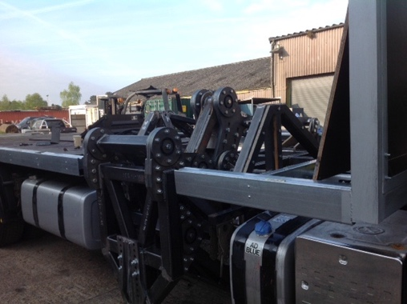
Tipping Semi Truck.
We rigged a hydraulic trailing arm underneath the semi-truck so that as the truck took the turn the stuntman could flick a switch that operated the trailing arm which then gradually flipped over the truck.

X, Y, Truck Rig.
We rigged the truck body on to a rig that would move 3 feet in an X, Y motion very fast. This was to simulate the stop – start of the truck and also right left motion to simulate the truck driving around the streets of Paris

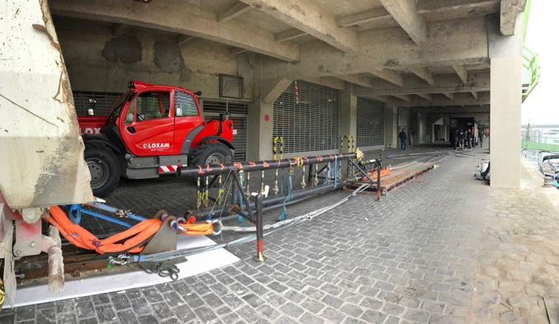
Truck T Bone Sequence.
This was a complicated shot for us as Tom Cruise want to drive the truck into the impact. For this we rigged up a cable system linking the prison truck to TC’s truck using the prison truck as the tow truck. We also had a hydraulic decelerator rigged to the back of the prison truck and also to the rear of TC’s truck so that on the moment of impact both vehicles stopped instantly giving the illusion of a high-speed impact.

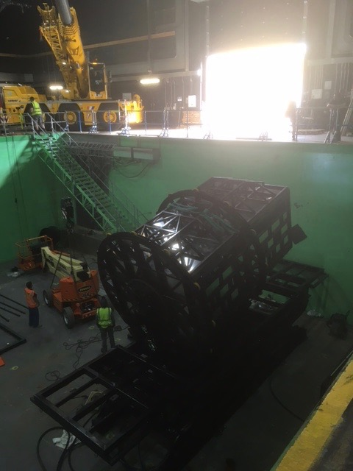
Sinking Revolving Truck Rig.
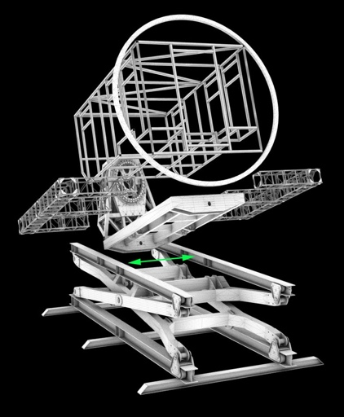
This was another complicated shot to achieve. Firstly, we prepared a Tech-Vis of this shot by building a 3D animation of our rig and simulating the movement and the sinking effect. Once this was signed off by the director we then went into production. We built a rotating rig that the set was built into. This was all mounted on a 20ft, 6-ton scissor lift which was then installed into a deep-water underwater stage tank.
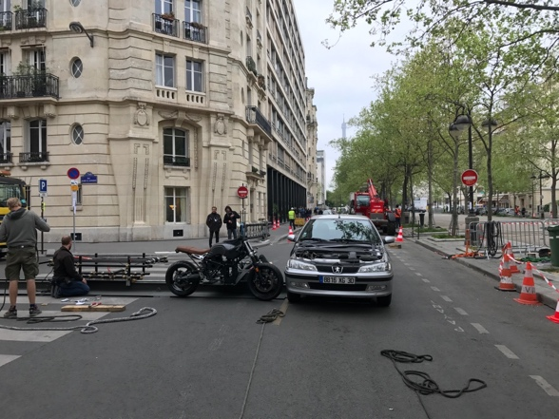
Motor Cycle T Bone Rig.
Another rig that TC wanted to do himself. We rigged a motorcycle on to a high-speed dolly that was then mounted on to a 60ft track. We used a similar wire system to the truck T-bone as in we attached the motorcycle to the car so that the impact point was the same every time. We then towed the car in using a 12ft nitrogen ramp with a hydraulic decelerator attached to the rear of the car. On the point of impact we installed a micro switch that initiated a small flipper ram that flipped the bike up on impact. TC’s was attached to a wire by stunts that gave him the protectory he needed to clear the car hood.
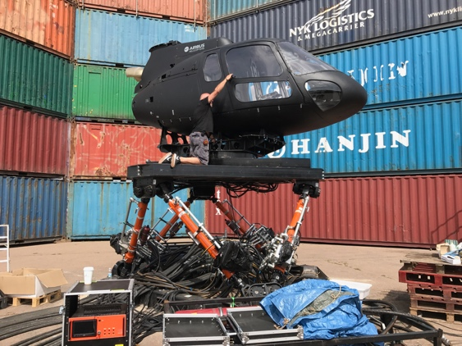

Helicopter Crash Sequence.
This was the most complicated sequence in the movie. We designed 9 individual special effects rigs to help create this sequence which included 2 x 6 axis motion bases. 2 x rotating rigs, one for each helicopter.

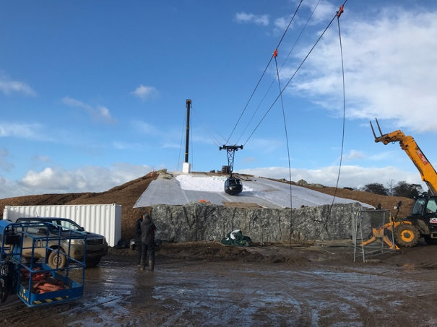

We built a 200m wire system that flew a full-size mock up down while rotating which in turn impacted the ground all while TC’s was inside.
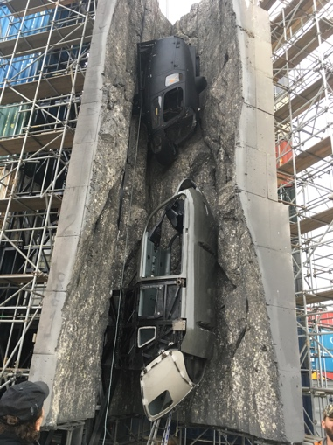
We attached 2 x rings to both types of helicopter so that they rolled down the hill in a straightish line which the VFX then removed.

We had another set where we mounted both helicopters vertically into a crevasse. The lower helicopter was on a vertical track and the upper helicopter was on a wire system. The upper helicopter was then dropped into the lower one dislodging it and then falling down below, again with TC inside the helicopters.

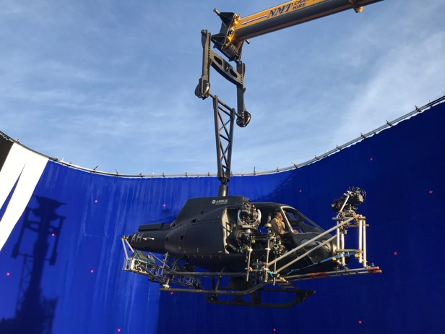

The mission Impossible series of movies are practically effects driven. We worked closely with the VFX department in creating as real as possible experience.

